Welcome in Drawfire manual!

Drawfire is simple drawing application that let you draw on canvas in quick and easy manner. Its goal is to be small, simple, but also customisable.

Originally made as a way to showcase Nimfire framework (from which Drawfire took name from), but then it became its own thing I enjoyed making - giving myself a bit restrictive goal to make the app as minimal, yet useful, as possible.
While Drawfire don't support many features you'd expect from basic drawing app, it tries to give unique experience to the user within its minimal characteristics, making those as a feature to overcome than a drawback.

Table of contents:

- How to use Drawfire?
- Brushes
- Keyboard
- How can I customise Drawfire elements?

How to use Drawfire?
When you open Drawfire, you are welcomed by such screen:
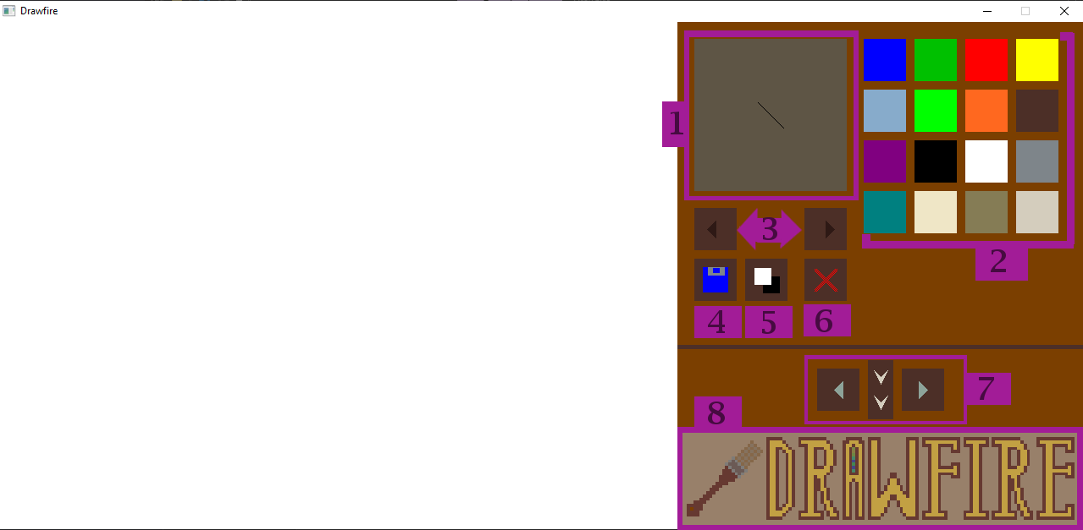
On left side, you have your canvas - they can be white or black, depending on transparency mode. You can freely draw with mouse on it!
Mouse drawing is button agnostic, meaning you can do it with either left or right one - so it's friendly system for both left- and right-handed people.

However, there are many options letting you customise your drawing experience:

1 - Brush view - shows your currently used brush, with its shape, colour and size showcased on gray background.
2 - Colour palette - 16 colours on 4x4 grid that showcase your current palette. Can be customised, which is explained in more detail later.
3 - Brush switch - left and right button helpful with changing brush shape. You can also use left and right arrow on keyboard. You can search for brush types below.
4 - Save button - button that let you save your current image. Images are saved as image[number].png file and each time they are saved as separate image - meaning whenever you save, change your image and save it again, you will actually make a copy of previous version. While this may not sound friendly at first, it let you work on images without fear of overwriting, as separate entities, and track your changes.
5 - Transparency switch - let you switch image's transparency between white canvas and transparent one (default to black, but it will not be visible on final save). Important: switching transparency is not possible while drawing, so switching transparency will clear your current image.
6 - Clear the canvas - this button lets you clear the canvas
7 - Load buttons - buttons that let you load images saved. They load only images saved in Drawfire's system (called as image[number].png and having up to 800x600 resolution), but arrow buttons let you switch between them, making whole system similar to image browsing - which is yet again feature allowing you to quickly conceptualise over your past sketches. Loading the image does not mean overwriting in case you edit the image - saving after the load creates yet another copy.
8 - Drawfire logo - while this may sound silly, Drawfire logo is actually element of GUI letting you open Drawfire's GitHub release page in your default browser. You can use this if you'd like to check if there's any updates available for your version of Drawfire.

Brushes
Drawfire implemented eight default brushes, four basic and four dynamic ones. Here is the list of each:

Image | Name | Description
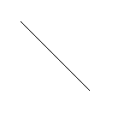 | Slash | Default brush.  Creates single slash shape.  Doesn't work dynamically.
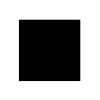 | Square | Square brush. Creates pixel-like marks.  Doesn't work dynamically.
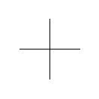 | Cross | Cross brush. Creates interesting swirls when moved.  Doesn't work dynamically.
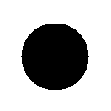 | Circle | Circle brush.  Doesn't work dynamically.
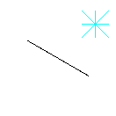 | Dynamic Cyan | Dynamic brush that is rotated manually, by use of "[" and "]" keyboard keys.
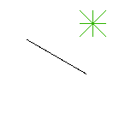 | Dynamic Green | Dynamic brush that operates on X axis. Drawing with it on them makes it rotate.
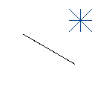 | Dynamic Blue | Dynamic brush that operates on Y axis. Drawing with it on them makes it rotate.
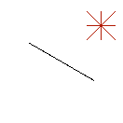 | Dynamic Red | Dynamic brush that operates on both X and Y axis, making spike-like shapes when drawn with.

Keyboard

Key | Use
Mouse | Use any of mouse buttons to draw
Tab | Save image
Q | Clears canvas
T | Switch image transparency (clears current canvas)
^ / v | Change brush size
< / > | Change brush type
[ / ] | Change brush rotation (only with Dynamic Cyan)

How can I customise Drawfire elements?
Currently, you can create your own palette by creating colours.json file in directory of your Drawfire app. You can simply use your Notepad for it, just remember to make it have json extension, not default txt one.

Paste such structure into your empty palette file:

{
"1": [0, 0, 255],
"2": [0, 192, 0],
"3": [255, 0, 0],
"4": [255, 255, 0],
"5": [135, 171, 203],
"6": [0, 255, 0],
"7": [255, 104, 31],
"8": [76, 47, 39],
"9": [128, 0, 128],
"10": [0, 0, 0],
"11": [255, 255, 255],
"12": [126, 133, 138],
"13": [0, 128, 128],
"14": [239, 230, 198],
"15": [133, 124, 85],
"16": [212, 205, 189]
}

Next step is to replace RGB values of each slot by your desired ones - replace values within square brackets, keeping other ones intact.

You can go back to default colours simply by changing name of the file, so you don't need to get rid of your palette once you made it.
In next Drawfire versions, a way to use many palettes will be added, making it easy to swap between them mid-drawing and without need to rename those to switch.
However, this is yet a feature in development, same as custom brushes. Keep your eyes open for upcoming Drawfire updates for those!

